9920 Stardust Trail, Little Rock, AR 72209
Stars below represent properties under management by Turnkey Property Management
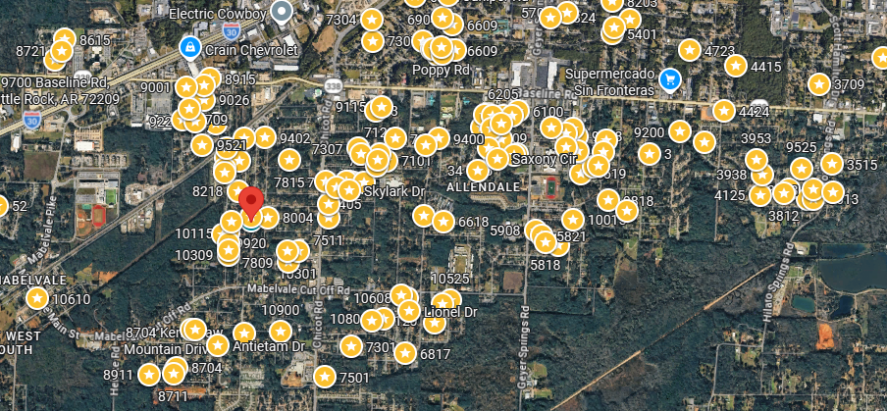
Bed/Bath: 3/2
Square Foot: 1,376
Year Built: 1975

Area Overview: Mabelvale was originally a small town with a train station on the southwestern edge of Pulaski County. It was annexed into the city of Little Rock in the 1970s and 80s. Now a suburb of Little Rock, Mabelvale is desirable to homeowners and renters alike. The area has a quiet and peaceful vibe, having retained a rural, small-town feel despite being located just a couple miles from major travel corridor I-30, Home Depot, Wal-Mart and the Gateway Town Center with75 outlet stores and Bass Pro Shops. Residents from all over Little Rock are drawn to Mabelvale’s Three Sams Barbecue and Catfish, with its rustic ambiance, situated right on the old railroad track.
HVAC – 2018
Hot Water Heater –New
Roof – New

