938 Bramblewood Lane, Memphis, TN 38109
Stars below represent properties under management by CB Properties - Memphis, TN
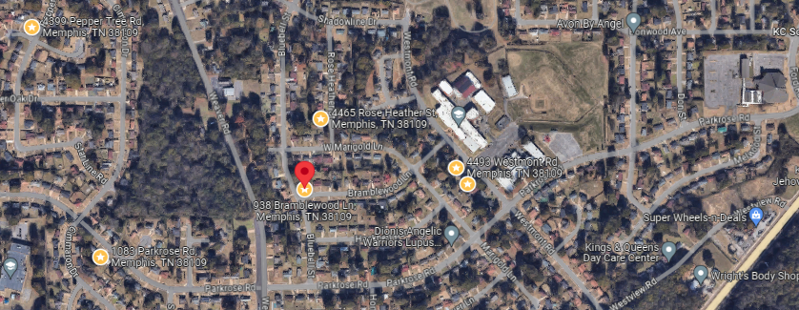
Bed/Bath: 3/1.5
Square Foot: 1,131
Year Built: 1961

Area Overview: This home is located in the Westwood neighborhood of Memphis. It is off
Highway 61 near the TN/MS state line - about 10 minutes from the airport area. It is also a short commute to the Tunica Casinos in Mississippi.

Resident moving in on June 18, 2026
Sewer line was inspected in 2024 and in good working order

