2872 Churchill Street, Memphis, TN 38118
Stars below represent properties under management by CB properties
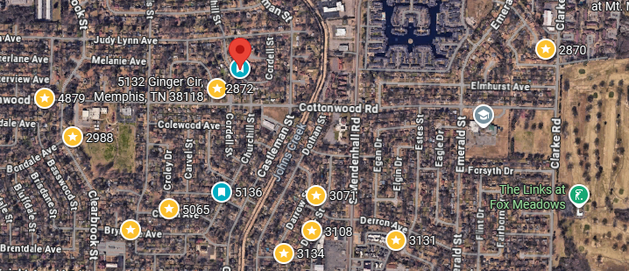
Bed/Bath: 3/1.5
Square Foot: 1,321
Year Built: 1964

Area Overview: This home is is southeast Memphis. What we like about the area is the history we have in the neighborhood of quick renting, which is a common theme for houses inside and close to the 240 loop. The area is close to I-240, which gives quick access to most parts of the city within 25 minutes, including the airport/Fed Ex area and other logistics jobs that is the driver of the Memphis economy in 15 minutes. It is just East of the Memphis airport.

HVAC, Hot Water Heater and Roof all about 10 plus years old
This home is occupied through November of 2026.

