20 Grant Oaks, North Little Rock, AR 72120
Stars below represent properties under management by Turnkey Property Management
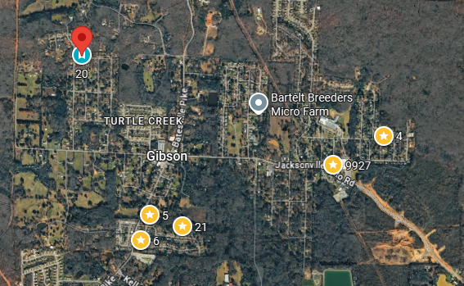
Bed/Bath: 3/2
Square Foot: 1,694
Year Built: 1975

Area Overview: The city of Sherwood is a direct neighbor of the City of North Little Rock. Many people can’t tell when they have left North Little Rock and entered Sherwood, as they share many amenities, employers, roads and highways. The two cities have grown simultaneously. Peaceful and family friendly with lush green spaces all conveniently located. This would be considered a Class B or strong Class C area.

HVAC – 2014
Hot Water Heater –New
Roof – less than 5 years old
Sewer line inspected clean out installed
Utilities and yard maintenance are not calculated in the cash flow*

