2 Laramie Cove, Sherwood, AR 72120
Stars below represent properties under management by Turnkey Property Management
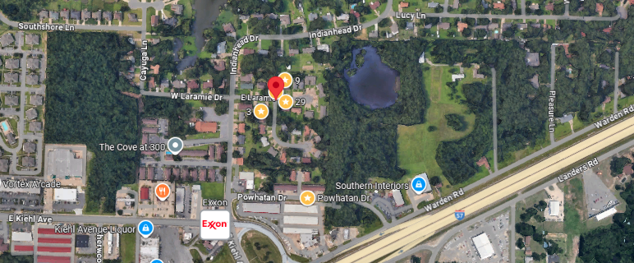
Bed/Bath: 2/1 each unit
Square Foot: 2,711
Year Built: 1971

This TriPlex will have a new roof.
Unit A is leased through August of 2027
Unit B’s lease is through June 30, 2026
Unit C’s lease is through September 30, 2026

Unit A - Hot Water Heater – 2022, Furnace – will be new - 2025, A/C – 2011
Unit B – Hot Water Heater – 2024, Furnace – will be new - 2025, A/C – 2013
Unit C – Hot Water Heater – 2020, Furnace – will be new - 2025, A/C - 2016

