4652 Percy Road, Memphis, TN 38109
Stars below represent properties under management by CB properties
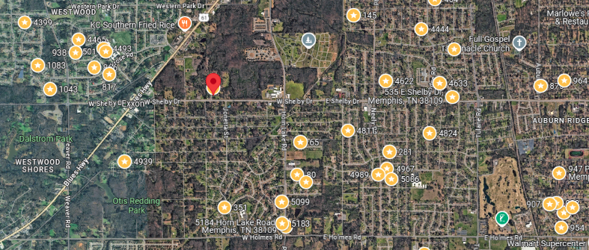
Bed/Bath: 2/1
Square Foot: 811
Year Built: 1955

Area Overview: This property is located in the Whitehaven area of Memphis Whitehaven is best known globally for Graceland, but locally, it is known for its residents’ pride in living within the Whitehaven area and for locally-owned minority businesses. The houses are typically larger, with covered parking and a floor plan that, along with our renovation, helps properties to rent fast. Most houses in Whitehaven are 10 minutes from the airport area, which is a source for thousands of jobs. Whitehaven is the largest community that is close to the Tunica Casinos in Mississippi, also a source of thousands of jobs. Tenants in Whitehaven can reach downtown or midtown within 15 minute

HVAC – 2019
Hot Water Heater – New
Roof - New

