7307 Knowllwood Rd, Little Rock, AR 72209
Stars below represent properties under management by Turnkey Property Management
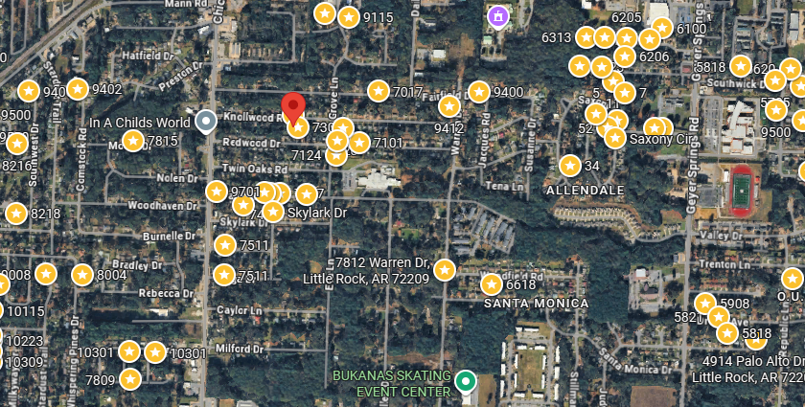
Bed/Bath: 3/1
Square Foot: 912
Year Built: 1963

Area Overview: Southwest Little Rock is one of the most culturally and economically diverse sections of the city. The Arkansas Times recently published “If the River Market is our Manhattan and Hillcrest is our Brooklyn, consider Southwest Little Rock our Queens. The Arkansas Times article pointed out the cultural diversity. The area is home to many of our minority groups, including a large number of Latinos, as well as many working class/blue collar families reside here. Recently, the Little Rock Children’s Hospital constructed a $4 million primary care clinic there, with an emphasis on providing a bilingual staff to service the local community. SWLR is also home to the Arkansas Department of Transportation Headquarters and the Arkansas State Police Headquarters. Numerous warehousing, manufacturing and industrial business call SWLR home.
HVAC – 2021
Hot Water Heater – 2020
Roof - 2022
Occupied as of February 26, 2026 on a 2 year lease

