2992 Bannockburn Road, Memphis, TN 38128
Stars below represent properties under management by CB properties
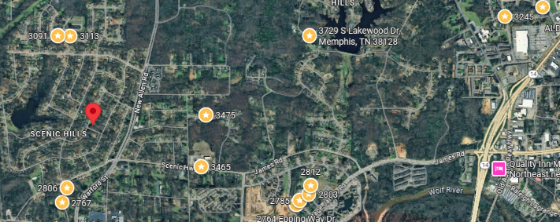
Bed/Bath: 3/2
Square Foot: 1,539
Year Built: 1958

Area Overview: This property is located in the Raleigh area of Memphis (38128). Like many other neighborhoods in Memphis, Raleigh residents (not to be confused by Raleigh-Frayser or anything west of Raleigh Millington Road) love the area and do not have interest in living anywhere else. Although near the Nike DC, Raleigh's business community is almost exclusively retail. The southern section of Raleigh comprises Memphis's largest collection of automobile dealerships and related businesses, while the area around Stage Road offers fast food and casual restaurants, shopping centers, and major retailers such as Home Depot. Raleigh’s eastern border is shared with Bartlett, which many residents like as Bartlett has many choices to shop and dine. We like Raleigh east of Raleigh-Millington all the way to Bartlett.

A/C – 2014
Hot Water Heater – 2024
Furnace – 2010
Roof approximately 15 years old
Occupied through April of 2027

