1326 Whitewater Road, Memphis, TN 38117
Stars below represent properties under management by CB properties
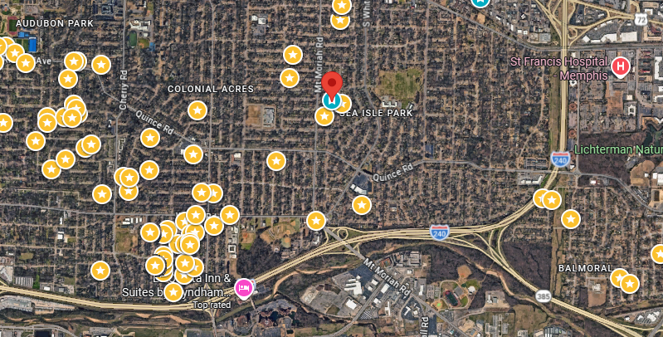
Bed/Bath: 3/2
Square Foot: 1,734
Year Built: 1954

Area Overview: The East Memphis area located conveniently close to I-240, the airport and many logistics-based jobs that comprise the backbone of the Memphis economy. Located 15 minutes from the airport, 20 minutes from downtown, 15 minutes from Midtown Cooper Young/Overton Square, and 15 minutes from Cordova or Germantown. East Memphis is a hub of many thriving companies & businesses including the International Paper complex. While East Memphis is home to some of the most expensive homes in the county, there are pockets that provide excellent cash flow in desirable areas. Our target neighborhoods include Colonial Acres, White Station- Summer, Balmoral, Audubon Park and Ridgeway

New Roof
Sewer inspected and in good shape
Approved Applicant to move in May 1, 2026

