110 N Monroe St, Cabot, AR 72023
Stars below represent properties under management by Turnkey Property Management
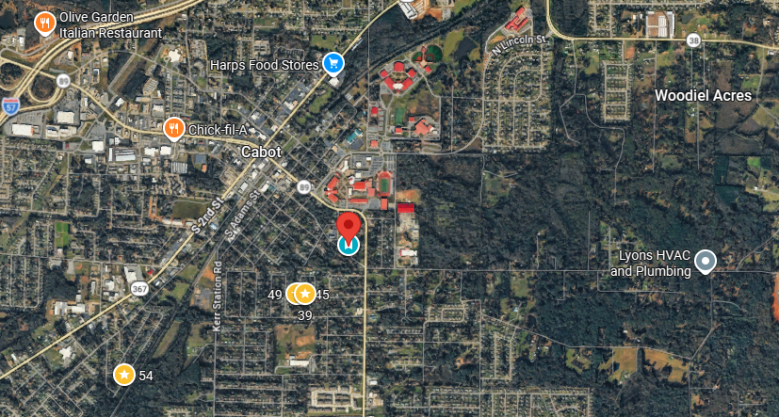
Bed/Bath: 4/2
Square Foot: 1,138
Year Built: 2026

Area Overview: Cabot is located 20 miles Northeast of Little Rock in Lonoke County. The population is about 23,000 people. Cabot has experienced phenominal growth from the 1980’s to today. One reason for this growth is the Air Force base, while another is the top rated school district. Cabot is home to many festivals including a strawberry one which is the favorite among the locals
New construction in Cabot, AR

