2715 S State Street, Little Rock, AR 72206
Stars below represent properties under management by Hoffman Properties
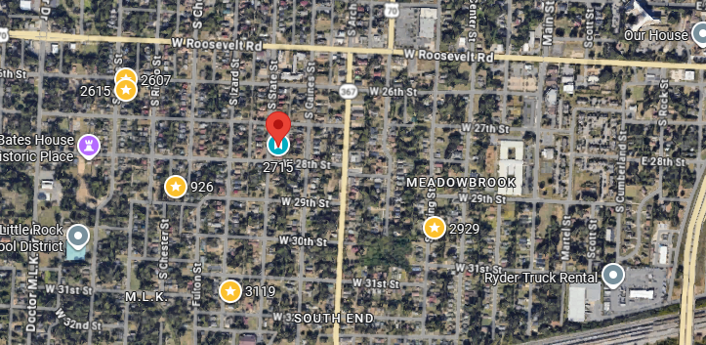
Bed/Bath: 4/2
Square Foot: 2,012
Year Built: 1917

Area Overview: Mid-town is anchored by the University of Arkansas (LR), University of Arkansas for Medical Sciences, Baptist and St. Vincent hospitals, new and existing shopping developments, 630 Freeway, city parks, LR Zoo, etc. The University of Arkansas for Medical Sciences (UAMS) is the home of Arkansas' only academic medical center, with clinics covering every medical specialty and a staff of more than 1,100 doctors.

