3151 Maple Hill Drive, Memphis, TN 38118
Stars below represent properties under management by CB properties
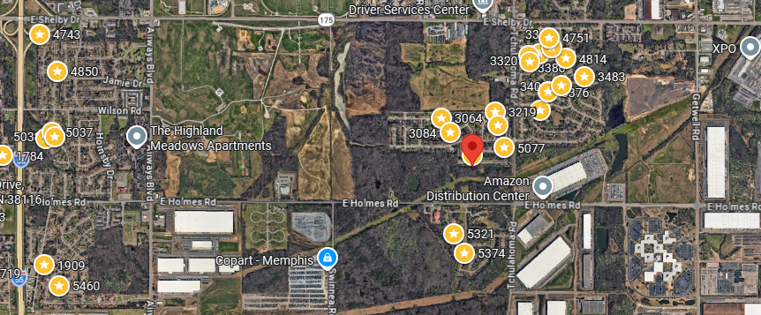
Bed/Bath: 3/2
Square Foot: 1,179
Year Built: 1973

Area Overview: This home is located in the Parkway Village area of Memphis. As you can see this home is a hop, skip and a jump to the Amazon Distribution center. This is a highly diverse area and is just east of the airport. We like this area as it is a good rental market. This is considered a B class neighborhood.

A/C – 2020
Furnace 2017
Hot Water Heater –2013
Roof – 10 – 15 years old
This home is occupied through October of 2026

