616 Shotwell Street, Memphis, TN 38111
Stars below represent properties under management by CB properties
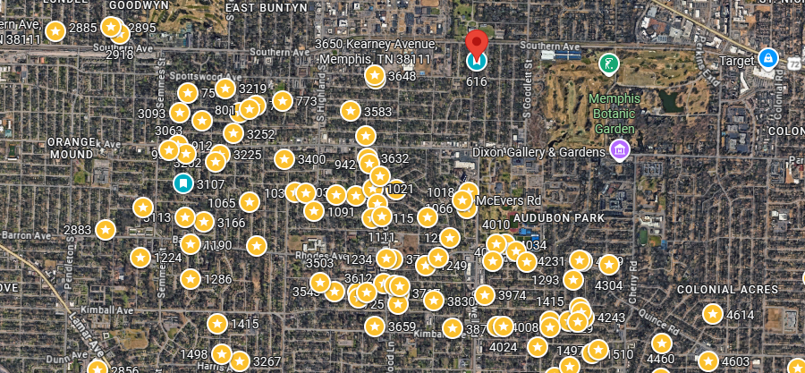
Bed/Bath: 3/2
Square Foot: 1,087
Year Built: 1948

Area Overview: This area of 38111 of East Memphis is located in the West end of East Memphis and is located conveniently close to I-240, the airport and many logistics-based jobs that comprise the backbone of the Memphis economy. Located 15 minutes from the airport, 20 minutes from downtown, 15 minutes from Midtown Cooper Young/Overton Square, and 15 minutes from Cordova or Germantown. East Memphis is a hub of many thriving companies & businesses including the International Paper complex. While East Memphis is home to some of the most expensive homes in the county, there are pockets that provide excellent cash flow in desirable areas.
This home is occupied through August 7, 2027

HVAC – 2017
Hot Water Heater –2017
Roof – 10 years

