202 Overland Trail, Jacksonville, AR 72076
Stars below represent properties under management by Turnkey Property Management
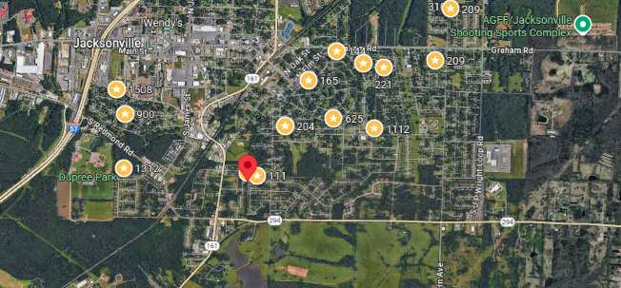
Bed/Bath: 3/1
Square Foot: 1,032
Year Built: 1972

Area Overview: Jacksonville is a suburb NE of Little Rock with a population of 28,364. About a 10-15 minute drive from downtown LR, the big selling point and driver on Jacksonville is the Little Rock Air Force Base located there. Many will be stationed there for several years before being transferred, so it is an ideal rental area. Little Rock AFB is the C-130 Hercules training base for the Department of Defense, training C-130 pilots, navigators, flight engineers, and loadmasters from all branches of the US military in tactical airlift and aerial delivery. The host unit at Little Rock AFB is the 19th Airlift Wing (19 AW), assigned to the Air Mobility Command 21st Expeditionary Mobility Task Force. The wing provides the Department of Defense the largest C-130 Hercules transport fleet in the world, supplying humanitarian airlift relief to victims of disasters, as well as airdropping supplies and troops into the heart of contingency operations in hostile areas.

