1704 Garfield Ct, Little Rock, AR 72204
Stars below represent properties under management by Turnkey Property management
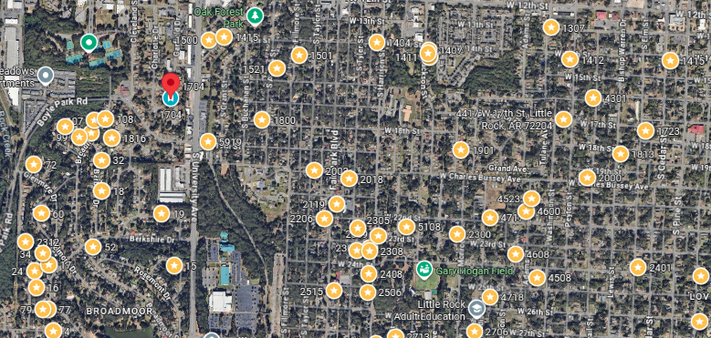
Bed/Bath: 4/2
Square Foot: 1,272
Year Built: 1979

Area Overview: Broadmoor is bordered by Boyle Park to the west. This is a 250 acre city park with walking trails, streams, and play areas. This is a great location as Mid-town, has easy access to nearby major interstate and freeway, shopping, etc. The neighborhood is bordered by University of Arkansas at Little Rock to the east, with over 13,000 students and faculty. The university continues to expand and invest in the area.

New Roof
HVAC – will be new
Hot Water Heater – 2023
Sewer to be inspected

