17 Fairmont Drive, Little Rock, AR 72204
Stars below represent properties under management by Turnkey Property management
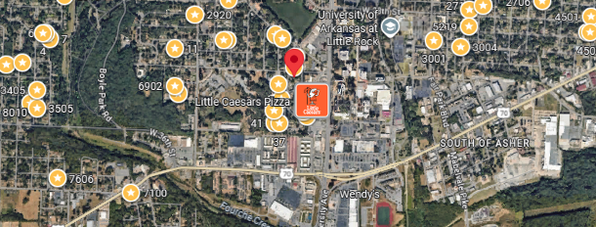
Bed/Bath: 3/1
Square Foot: 1,008
Year Built: 1959

Area Overview: The 3 BIG points of Broadmoor are:
- Location: Mid-town, easy access to nearby major interstate and freeway, shopping, etc.
- Neighborhood is bordered by University of Arkansas at Little Rock to the east, with over 13,000 students and faculty. The university continues to expand and invest in the area. Broadmoor is bordered by Boyle Park to the west. This is a 250 acre city park with walking trails, streams, and play areas.
- Active neighborhood association, high percentage of homeowners = stability and appreciation in home values over the long run

