819 Willett Avenue, Memphis, TN 38107
Stars below represent properties under management by CB properties
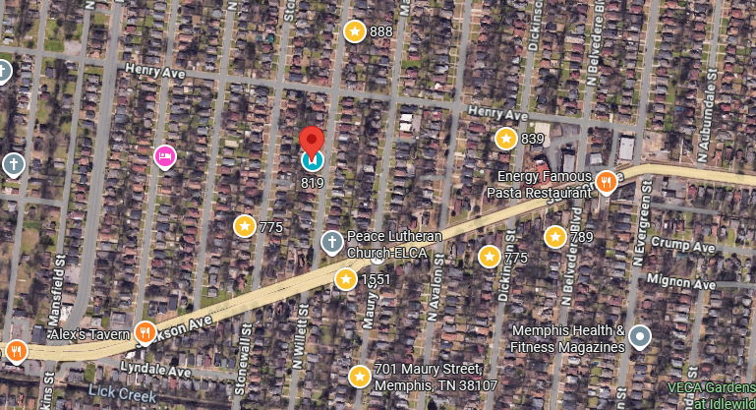
Bed/Bath: 3/2
Square Foot: 1,831
Year Built: 1932

Area Overview: This area of Memphis is close to downtown with easy access to the medical district. This is a tight knit community with dedicated residents. Last renovated in 2018.
HVAC and Hot Water Heater – 2018
Roof – 2024
Lease expires in July.

