7 Fairbrook Drive, Little Rock, AR 72205
Stars below represent properties under management by Turnkey Property Management
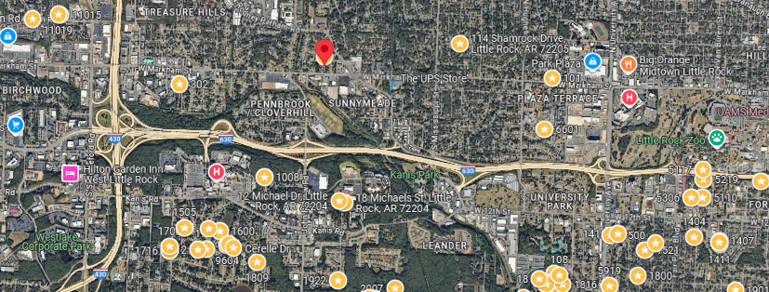
Bed/Bath: 4/2
Square Foot: 1,902
Year Built: 1962

Area Overview: Mid-town is anchored by the University of Arkansas (LR), University of Arkansas for Medical Sciences, Baptist and St. Vincent hospitals, new and existing shopping developments, 630 Freeway, city parks, LR Zoo, etc. The University of Arkansas for Medical Sciences (UAMS) is the home of Arkansas' only academic medical center, with clinics covering every medical specialty and a staff of more than 1,100 doctors.

Sewer inspected and in good working order
New Roof
Furnace – 2014
A/C – New
Hot Water Heater 2019

