6233 Cranbury Park Drive, Memphis, TN 38141
Stars below represent properties under management by CB properties
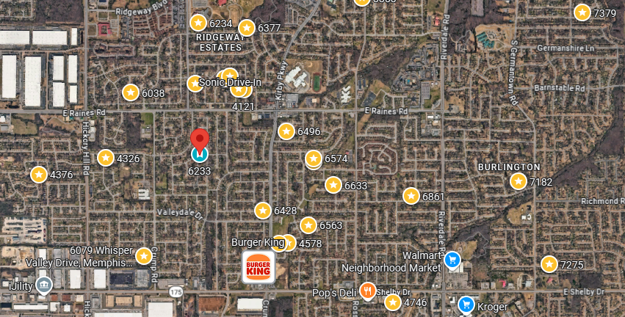
Bed/Bath: 3/2
Square Foot: 1,322
Year Built: 1975

Area Overview: This specific area of 38141 has done well for us as properties have rented quickly and within the market rent range. Located in SE Shelby County, this area is known for newer developments located near many warehouse districts, a good source of employment. Located near Bill Morris Parkway / 385, you can reach the suburbs in 15 minutes, airport in 15 minutes and downtown in 20 minutes. This is a very desirable place to live for tenants looking at rents of $1,000 and up!
Occupied through October of 2027

