4600 Lynn Lane, North Little Rock, AR 72118
Stars below represent properties under management by Turnkey Property Management
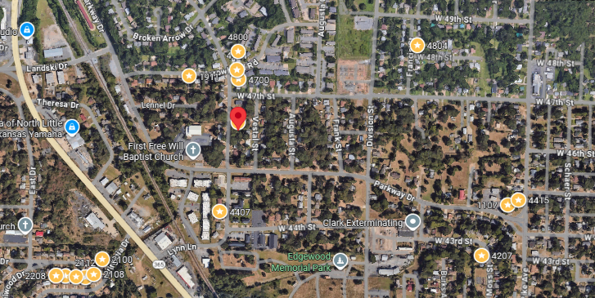
Bed/Bath: 3/1.5
Square Foot: 1,168
Year Built: 1960

Area Overview: Just across the Arkansas River, running through Downtown Little Rock lies North Little Rock, a suburb of Little Rock, with a population of approximately 66,000. Conveniently located to I-30/I-40 and Hwy 167, one has easy access to the Northern Suburbs and to the city of Little Rock, including the downtown River Mart. To the West is Burns Park, the largest municipal park in the state of Arkansas. North of Burns Parks is Air National Guard Military Base, Camp Robinson. Like most suburbs, individuals living in NLR enjoy being part of a smaller community and schools. Argenta Historic District, which is considered downtown Little Rock, has an old, slow-paced town square feel. Other points of interest include Verizon Arena, which is home of the UALR basketball team and big concert venue, McCain Mall, Arkansas River Trail and Dickey-Stephens Park, home of the Arkansas Travels, the local AA baseball affiliate of the Seattle Mariners.

New Roof
HVAC – 2024
Hot Water Heater – 2021
New sewer line
Occupied through February of 2028

