2511 Montreal Drive, Little Rock, AR 72204
Stars below represent properties under management by Turnkey Property Management
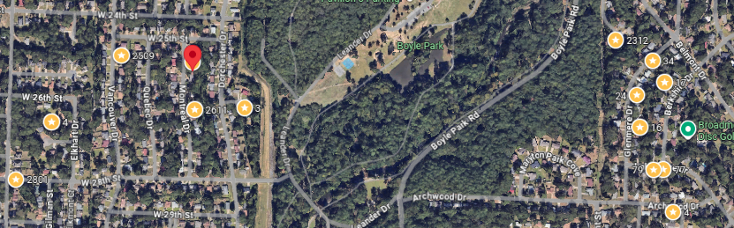
Bed/Bath: 3/2.5
Square Foot: 1,596
Year Built: 1969

Area Overview: The John Barrow Addition of Little Rock is a neighborhood in the western portion of the city, named for its main thoroughfare, John Barrow. It is bordered on the north by I-630, on the west by I-430, on the east by Boyle Park, and on the south by Asher Avenue. Nearby neighborhoods include Briarwood to the north and Rosedale to the south, while to the east sits Broadmoor and the vicinity surrounding the University of Arkansas at Little Rock. To the north sits Baptist Health Medical Center and its campus of physician offices and surgery centers. The entire area is basically an extension of Midtown. Nearby shopping developments include Midtown Mall/Park Avenue and Shackelford Crossing lies to the immediate east and west of the area. There is also easy access to two major freeways (430 and 630).

Hot Water Heater – 2022
HVAC – 2011
Metal Roof

