206 Neely Cove, Memphis, TN 38109
Stars below represent properties under management by CB properties
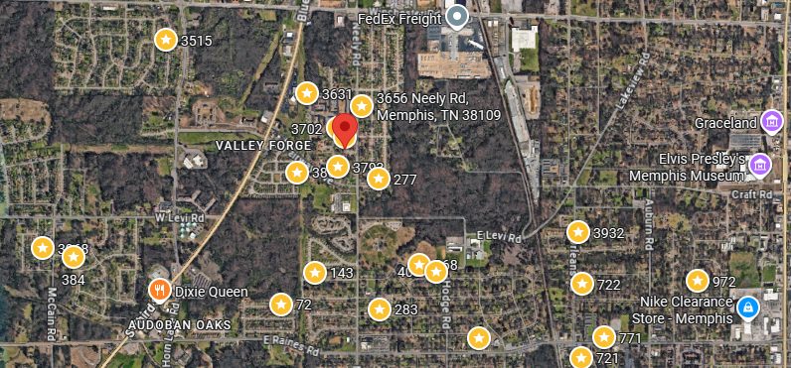
Bed/Bath: 3/1.5
Square Foot: 1,340
Year Built: 1967

Area Overview: This property is located in the just outside the Whitehaven area of Memphis, best known globally for Graceland, but locally, it is known for its residents pride in living within the Whitehaven area and locally owned minority businesses.
This home was Turnkeyed in 2018 -Roof, Hot Water Heater and HVAC were all installed then. This home is occupied through May of 2026

