14 S Wakefield Drive, Little Rock, AR 72209
Stars below represent properties under management by Turnkey Property management
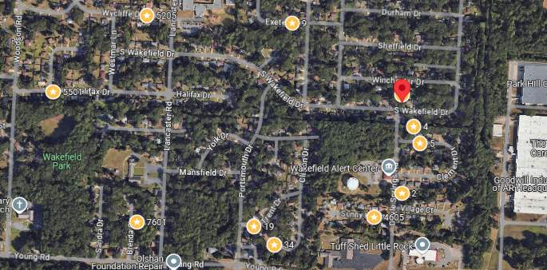
Bed/Bath: 3/1.5
Square Foot: 1,248
Year Built: 1960

Area Overview: This home is located in the Wakefield neighborhood in Southwest, Little Rock. Southwest Little Rock is one of the most culturally and economically diverse section of the city. The Arkansas Times recently published “If theRiver Market is our Manhattan and Hillcrest is our Brooklyn, consider Southwest Little Rock our Queens.."

Roof is approximately 7 years old
A/C – 2020
Furnace – 2019
Hot Water Heater – 2020
Sewer inspection performed all checked out ok
Occupied as of 8/20/25 through 8/20/2027

