12 S Wakefield Drive, Little Rock, AR 72209
Stars below represent properties under management by Turnkey Property management
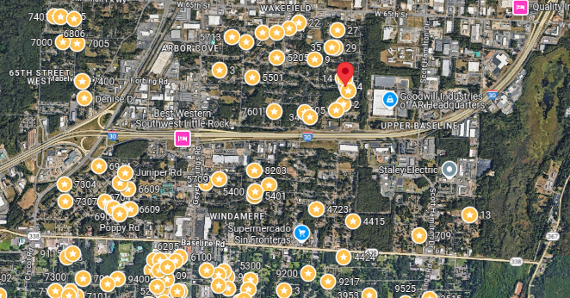
Bed/Bath: 4/1.5
Square Foot: 1,200
Year Built: 1960

Area Overview: This home located in the Wakefield neighborhood in Southwest, Little Rock. Southwest Little Rock is one of the most culturally and economically diverse section of the city. The Arkansas Times recently published “If the River Market is our Manhattan and Hillcrest is our Brooklyn, consider Southwest Little Rock our Queens.."

