11 W Rollins Road, Memphis, TN 38109
Stars below represent properties under management by CB properties
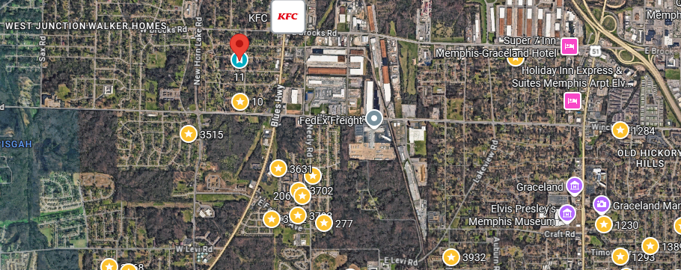
Bed/Bath: 3/1
Square Foot: 943
Year Built: 1971

Area Overview: This property is located in the just outside the Whitehaven area of Memphis, best known globally for Graceland, but locally, it is known for its residents pride in living within the Whitehaven area and locally owned minority businesses.
Occupied through August of 2027

