1053 Fleece Place, Memphis, TN 38104
Stars below represent properties under management by CB properties
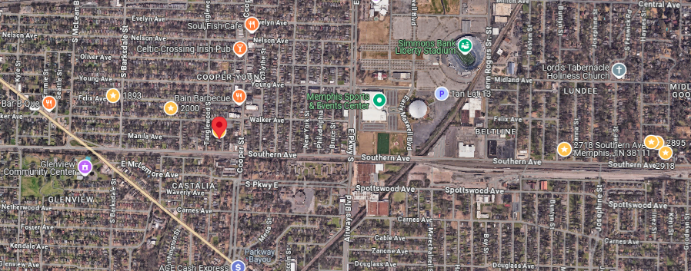
Bed/Bath: 1 bed 1 bath each side
Square Foot: 1,510
Year Built: 1920

Area Overview: This duplex is located in the Cooper Young area of midtown Memphis. This area is described as both
traditional and trendy along with cosomopolitan and casual. Boutique shopping along with sophisticated restaurants thrive
in this historic neighborhood.

Roof – 2024
Hot Water Heater – 2024 and 2021
HVAC – 2016

Unit 1 is leased through May of 2026
Unit 2 is leased through September of 2026
Sewer inspected in 2024 and all ok

