3107/3109 Radford Road, Memphis, TN 38111
Stars below represent properties under management by CB properties
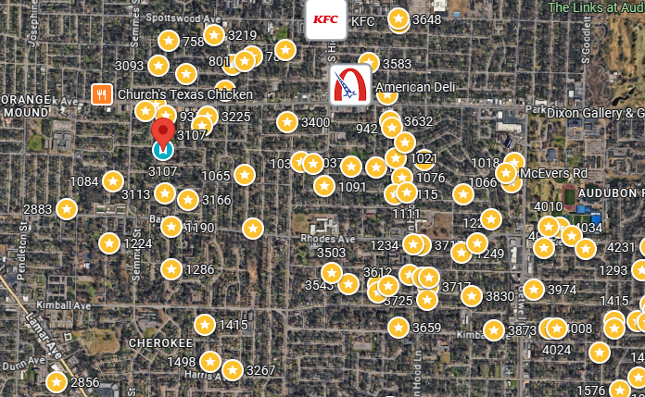
Bed/Bath: 2/1 each side
Square Foot: 1,686
Year Built: 1970

Area Overview: This area of 3811 is located conveniently close to I-240, the airport and many logistics-based jobs that comprise the backbone of the Memphis economy. Located 15 minutes from the airport, 20 minutes from downtown, 15 minutes from Midtown Cooper Young/Overton Square, and 15 minutes from Cordova or Germantown. East Memphis is a hub of many thriving companies & businesses including the International Paper complex.
3107 lease ends 11/10/26
3109 lease ends 9/2/27
A/C 2017 for 3107
Hot water heater 2020 – both sides
Furnace 2008 for 3107 and 2020 for 3109
Roof - 2023

