1905 Labette Manor Drive, Little Rock, AR 72205
Stars below represent properties under management by Turnkey Property Management
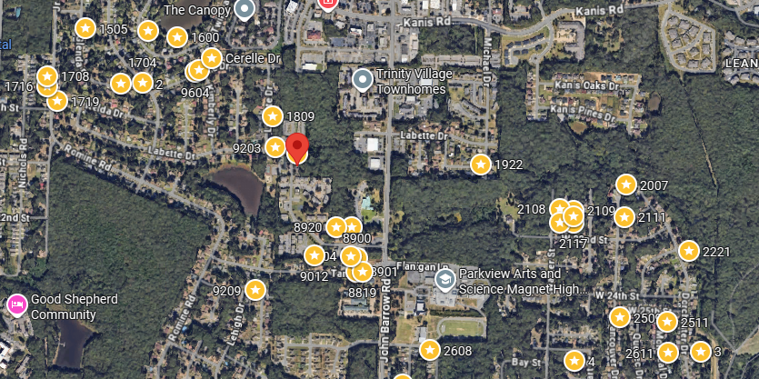
Bed/Bath: 2/1 each unit
Square Foot: 1,804
Year Built: 1979

Area Overview: The John Barrow Addition of Little Rock is a neighborhood in the western portion of the city, named for its main thoroughfare, John Barrow. It is bordered on the north by I-630, on the west by I-430, on the east by Boyle Park, and on the south by Asher Avenue. Nearby neighborhoods include Briarwood to the north and Rosedale to the south, while to the east sits Broadmoor and the vicinity surrounding the University of Arkansas at Little Rock. To the north sits Baptist Health Medical Center and its campus of physician offices and surgery centers. The entire area is basically an extension of Midtown. Nearby shopping developments Midtown Mall/Park Avenue and Shackelford Crossing lie to the immediate east and west of the area. There is also easy access to two major freeways (430 and 630)

HVAC – New
Hot Water Heater –New
Roof – approximately 5 years old
Sewer line inspected and all ok
Landscaping to be paid by the owner and is calculated in the Cash Flow Analysis

