3648 Kearney, Memphis, TN 38111
Stars below represent properties under management by CB properties
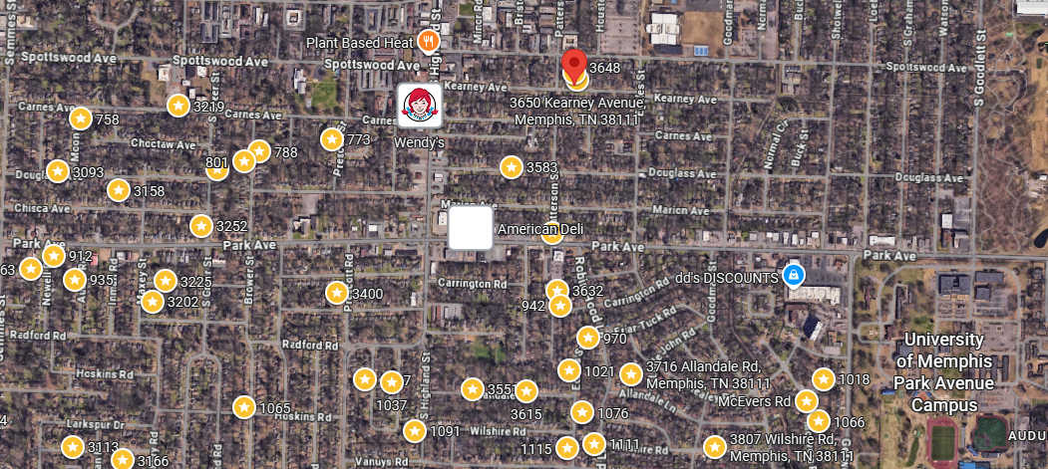
Bed/Bath: 4/3 -triplex
Square Foot: 2,581
Year Built: 1940

Area Overview: This area of 38111 of East Memphis is located in the West end of East Memphis and is located conveniently close to the University of Memphis, the airport and many logistics-based jobs that comprise the backbone of the Memphis economy. Located 15 minutes from the airport, 20 minutes from downtown, 15 minutes from Midtown Cooper Young/Overton Square, and 15 minutes from Cordova or Germantown. East Memphis is a hub of many thriving companies & businesses including the International Paper complex. While East Memphis is home to some of the most expensive homes in the county, there are pockets that provide excellent cash flow in desirable areas. Our target neighborhoods include Colonial Acres, White Station-Summer, Balmoral, Audubon Park and Ridgeway

3648 lease ends in Feb of 2028
3650 – lease ends in March 2027
Studio - lease ends in December o f 2026
Landscaping is paid by the owner and is factored in the cash flow analysis

