207 Gardenia Cove, Memphis, TN 38117
Stars below represent properties under management by CB properties
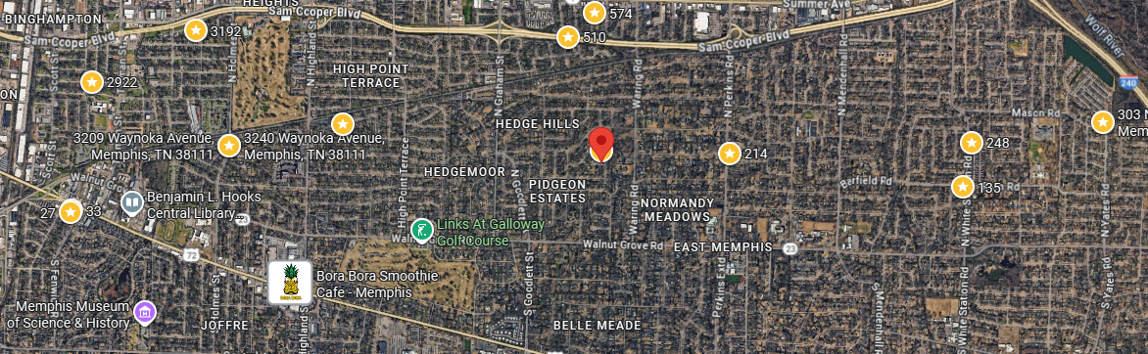
Bed/Bath: 3/2
Square Foot: 2,.094
Year Built: 1955

Area Overview: The East Memphis area located conveniently close to I-240, the airport and many logistics-based jobs that comprise the backbone of the Memphis economy. Located 15 minutes from the airport, 20 minutes from downtown, 15 minutes from Midtown Cooper Young/Overton Square, and 15 minutes from Cordova or Germantown. East Memphis is a hub of many thriving companies & businesses including the International Paper complex. While East Memphis is home to some of the most expensive homes in the county, there are pockets that provide excellent cash flow in desirable areas.

Lease will start March 26, 2026

