1769/1771 Edward Avenue, Memphis, TN 38107
Stars below represent properties under management by CB properties
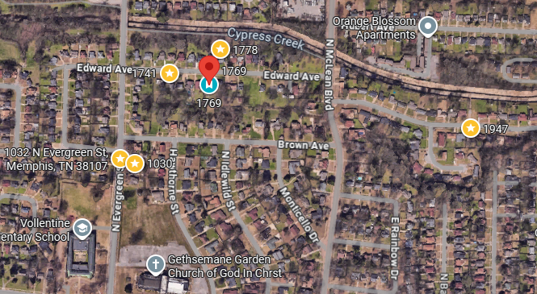
Bed/Bath: 2/1 each side
Square Foot: 1,965
Year Built: 1950

Area Overview: This home is located in Memphis’ Vollintine–Evergreen historic district, which is a large, diverse neighborhood in Midtown Memphis. It is known for its 1920’s craftman style homes and the fabulous Greenline which is a walking trail that runs through the city. The Vollintine Evergreen community actively works to maintain the neighborhoods historic aesthetic. This is close to major attractions such as the Overton Park, where the Zoo is, and Crosstown Concourse. New construction is being built just down the street!

1771 is being renovated and 1769 is occupied. Both sides have their own water meters and the property is electric with heat pumps. The brick will be repainted this Spring. In 2020 new windows, new roof, replumbed, new electrical, new mechanicals, and retiled the bathrooms. New flooring in 1769 in 2024, in 1771 being replaced now. Downstairs is vinyl plank, upstairs is carpet and tile is in the bathroom.

