650/652 Ayers Street, Memphis, TN 38107
Stars below represent properties under management by CB properties
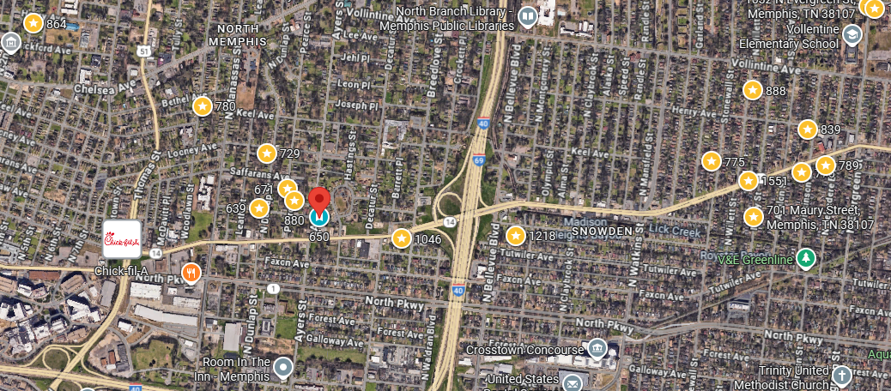
Bed/Bath: 4/2 each side
Square Foot: 1,665 each side
Year Built: 2025

Area Overview: This home is located in Memphis’ Vollintine–Evergreen historic district, which is a large, diverse neighborhood in Midtown Memphis. It is known for its 1920’s craftman style homes and the fabulous Greenline which is a walking trail that runs through the city. The Vollintine Evergreen community actively works to maintain the neighborhoods historic aesthetic. This is close to major attractions such as the Overton Park, where the Zoo is, and Crosstown Concourse.

