640 Leacrest Avenue, Memphis, TN 38109
Stars below represent properties under management by CB Properties - Memphis, TN
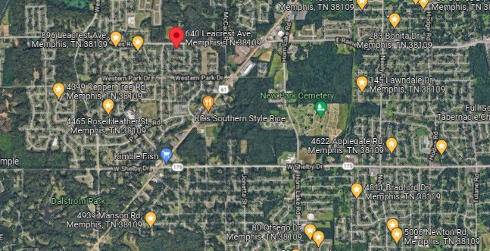
Bed/Bath: 3/1
Square Foot: 1,019
Year Built: 1959

Area Overview: This home is located in the Westwood neighborhood of Memphis. This home is off Highway 61 near the TN/MS Stateline. It is about 10 minutes from the airport area, which is a good source for jobs. It is also a short commute to the Tunica Casinos in Mississippi, which is a good source for jobs as well.

The renovation highlights include:

- The roof, HVAC and Hot water heater were all placed in 2021
This home is occupied through 10-30-27

