3496 Lynchburg Street, Memphis, TN 38135
Stars below represent properties under management by CB properties
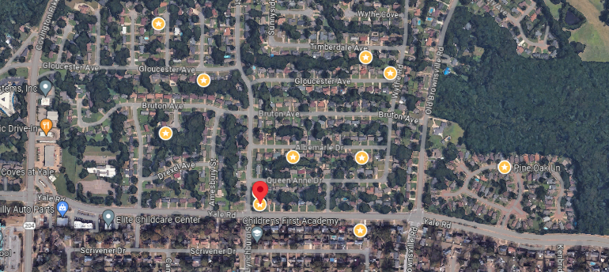
Bed/Bath: 3/2
Square Foot: 1,415
Year Built: 1969

Area Overview: This property is located in a very specific part of Memphis known as Raleigh-Bartlett. Raleigh is a large area stretching over three zip codes, with some areas we love and some where we absolutely will not go. This area is referred to as Raleigh-Bartlett because of its proximity to Bartlett (within approximately 1 to 2 miles), where we have a strong track record and significant number of homes managed. Main employers in the area are Methodist North, the world’s largest Nike DC facility and the automotive support industry, plus a large presence of retail outlets and offices.
HVAC – will be new
Roof – New
Sewer inspected - working properly
Hot Water Heater - New

Resident moving in February 2, 2026

