4112 Grey Road, Memphis, TN 38108
Stars below represent properties under management by CB properties
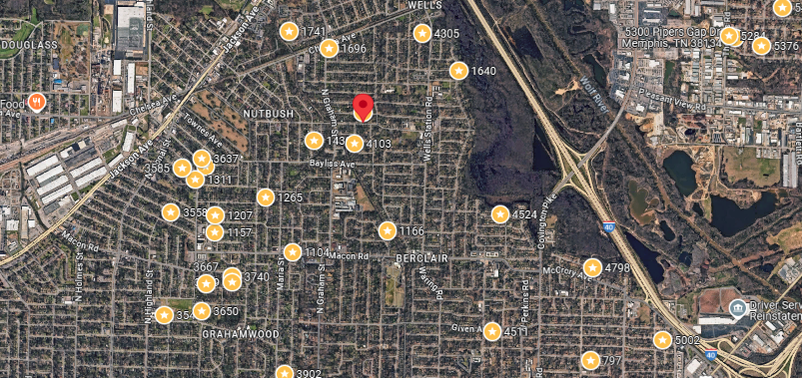
Bed/Bath: 2/1
Square Foot: 784
Year Built: 1952

Area Overview: This home is located in Berclair which is just North of Summer Avenue. It is only a 10 minute drive to Midtown or East Memphis.

Roof – in good condition
HVAC – New
Hot Water Heater - 2019

