6811 Skylar Mill Avenue, Cordova, TN 38018
Stars below represent properties under management by CB properties
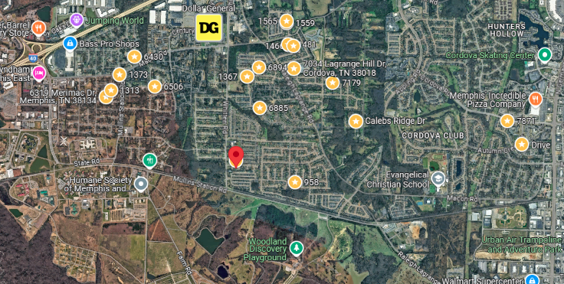
Bed/Bath: 3/2
Square Foot: 1,378
Year Built: 1999

Area Overview: This property is located in the Cordova area of Memphis (38018 and 38016). Known for its explosive growth in the 1990s, Cordova is one of the most popular areas for Memphians to move. This area has more dining and shopping than anywhere else in Memphis. There are now over 1,226 businesses with more than 19,400 employees working in Cordova. With four I-40 exits running through Cordova, the commute for individuals working in the heart of Memphis is only 15 to 20 minutes. You can reach downtown or the airport in 20 to 25 minutes. We like all of Cordova and do not target specific places to buy within these zip codes.

HVAC – will be new
Hot Water Heater – 2022
Front tear off on roof
Sewer inspected and all ok
Resident approved to move in March 17, 2025

