5913 Lyndell Drive, Little Rock, AR 72209
Stars below represent properties under management by Turnkey Property Management
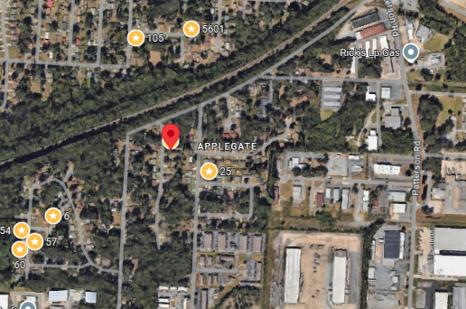
Bed/Bath: 3/1.5
Square Foot: 1,073
Year Built: 1967

Area Overview: Southwest Little Rock is one of the most culturally and economically diverse section of the city. The Arkansas Times article pointed out the cultural diversity. The area is home to many of our minority groups, including a large number of Latinos. Recently, the Little Rock Children’s Hospital constructed a $4 million primary care clinic there, with an emphasis on providing a bilingual staff to service the local community. The portion of city is home to many working class / blue collar families. These residents choose to live and work in SWLR for a variety of reasons. Reasons include the fact that SWLR hosts a diverse economy and Investments continue in the area.SWLR is also home to the Arkansas Department of Transportation Headquarters and the Arkansas State Police Headquarters. Numerous warehousing, manufacturing and industrial business call SWLR home
Roof – New
AC – 2023
Furnace – 2024
Hot Water Heater - New
New electrical panel

