17 Belmar Drive, Little Rock, AR 72209
Stars below represent properties under management by Turnkey Property management
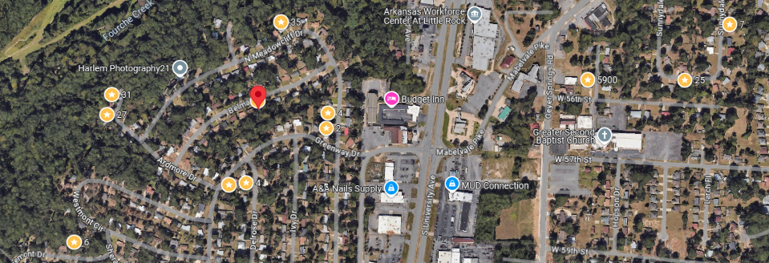
Bed/Bath: 3/1.5
Square Foot: 960
Year Built: 1955

Area Overview: Western Hills is centrally located and is known for its 127-acre city park along with other desirable natural elements ideal for outdoor activity. With a short drive, one can be in the Midtown area of Little Rock or close to major thoroughfares to get to most parts of Little Rock in under 20 minutes. Also located near Western Hills is located near Boyle Park, a 240 acre known for playgrounds, open meadows, woods, and numerous hiking and biking trails.

New HVAC
Metal roof in good condition
2016 – Hot Water Heater
Occupied through December 31, 2026

